DATASET:
Created the 20 different objects and then 100 variants each.
Then generated 9 views for each object.
Selected the correct views for each variant and created the STL images dataset.
Also created the Python macro files and CAD files.
LLM:
Looked for models that can generate the desired output.
Selected CAD Coder model because of its architecture which could be an advantage.
Downloaded the Pretrained CAD Coder model.
Fine tuned the CAD Coder model to fit it with our dataset and generate python macro script.
Loss obtained was 0.
Baseline Model:
We gave one of the dataset file to the CAD Coder to see how it works before performing the fine tuning. This is the image that was given and then the output that was obtained is as shown below of 2_004 and 1_001.
Input image (Combined view): Output:
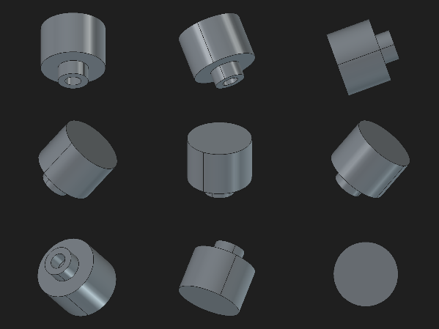 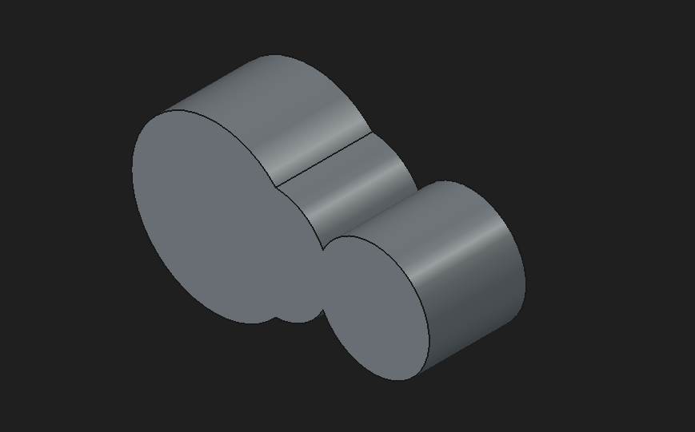
Input (single view): Output:
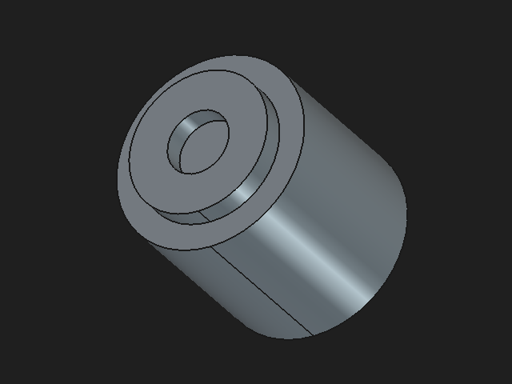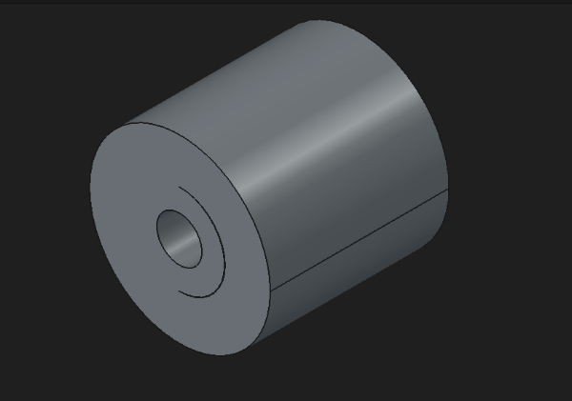
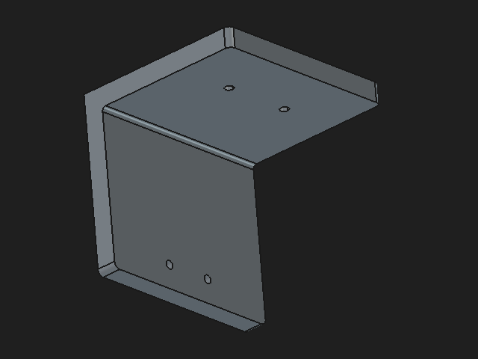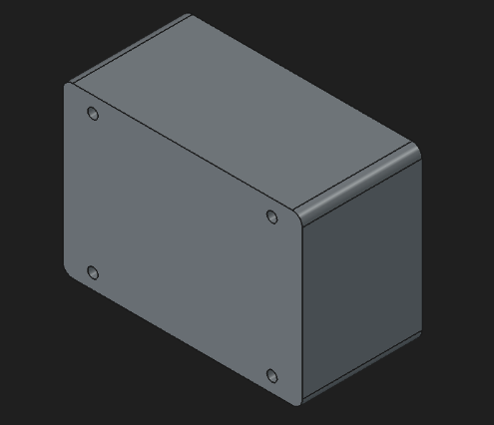

After fine tuning the model with our dataset (1_084):
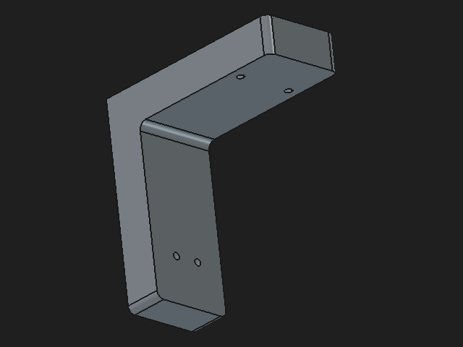` 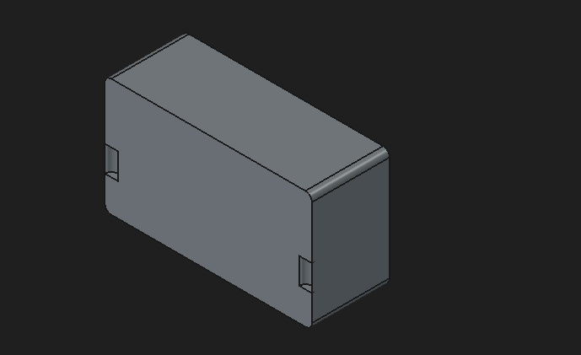
There is no fillet for one of the images like below (1_085 and 1_089):
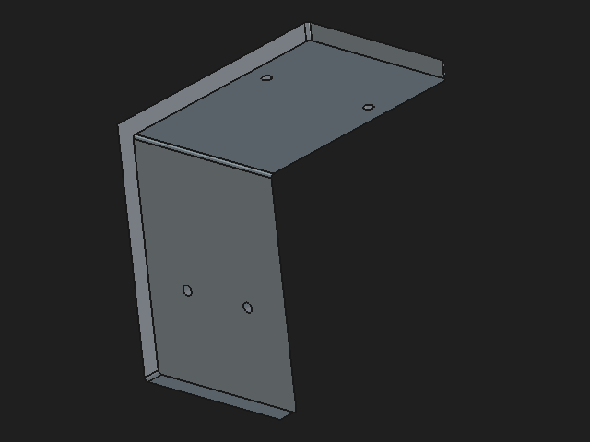` 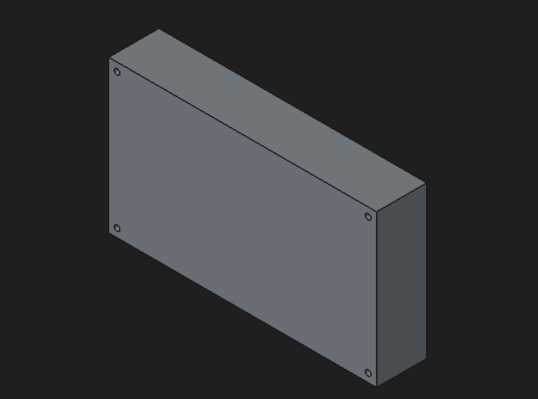
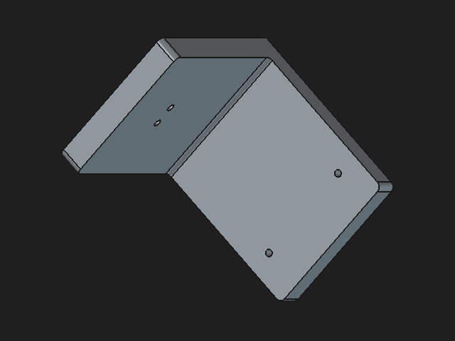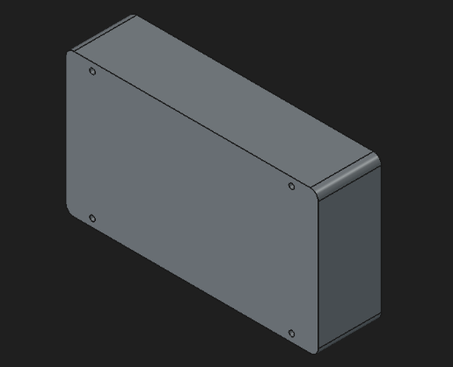

Good results were obtained too like the variants 1_91_v7 and 10_081 but there are also results like 10_082 and 10_085:
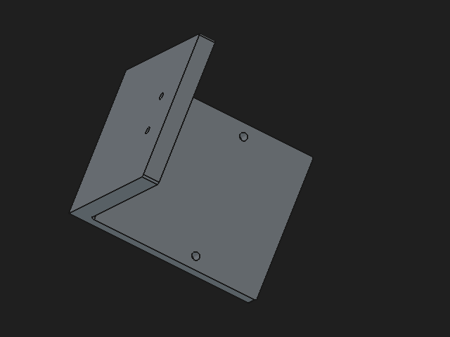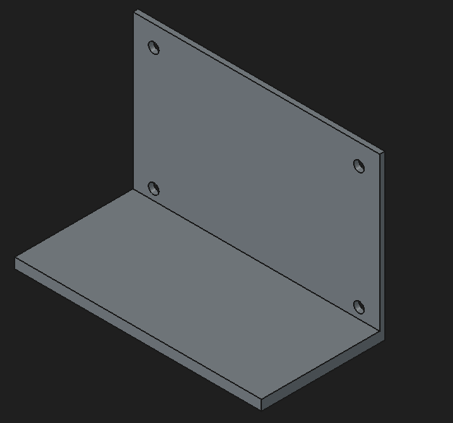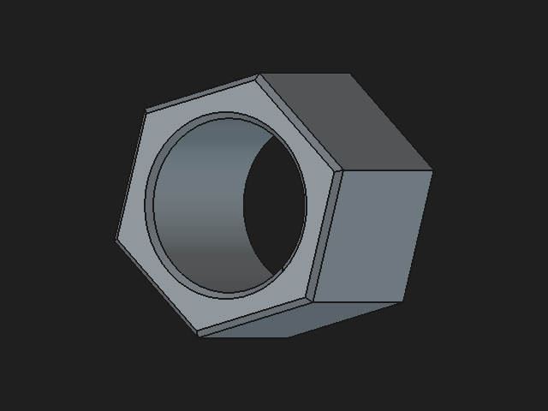 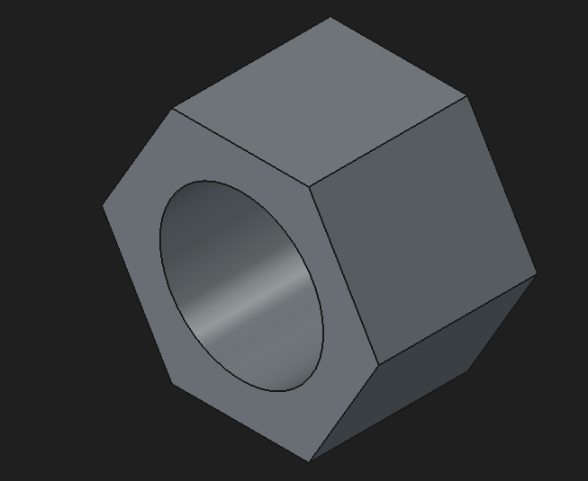
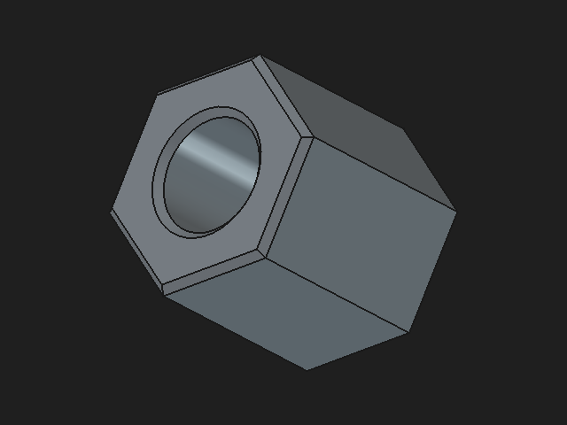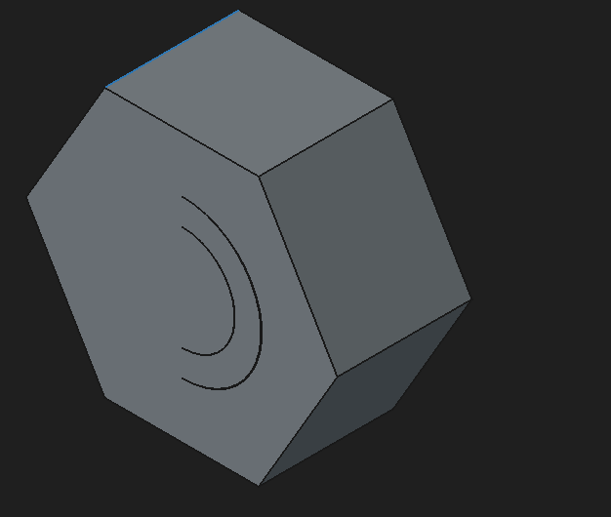
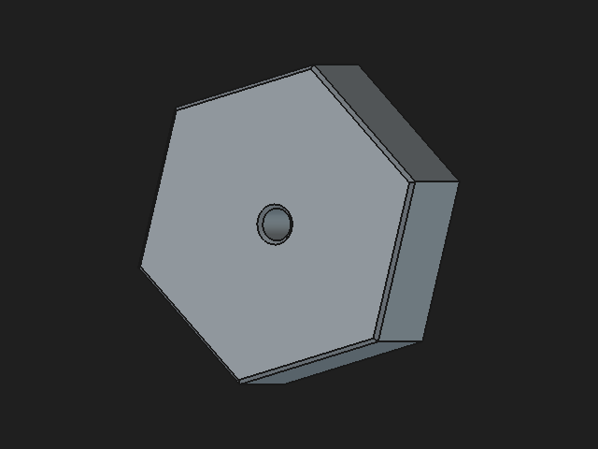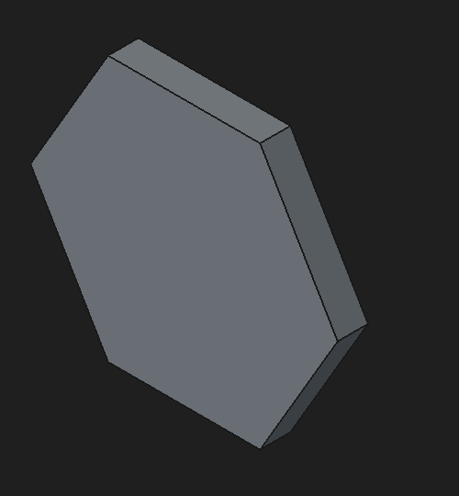
images are cheaper than the stl file so we are using that
CAD operations, Freecad documentation to see how the construction tree is constructed, mean error of no of cad operations, orientation (top view, bottom view), coordinate system to the single view along with geo data, python package for shape optimization.

CAD Coder architecture to be read
1. fine tune to get macro
2. give a cube and sphere to understand how it is constructed
3. test with our dataset
4. calculate error and no of cad operations
5. try with different orientations given, coordinate system, geo data combinations to see the result
6. shape optimization

